**Education: Setting a new course**

**By Kaushik Deka: June 12, 2023**

Education faced its biggest test ever when Covid-19 crept up on humanity with little warning. The transition to online learning had to take place almost overnight. India rose to the challenge commendably, given the enormity of the crisis. However, as it emerged on the other side of the pandemic, it found that the virus had taken a toll in more ways than one. The learning gap, for instance.

Economic disparity had widened that gap. Those who had access to technology moved ahead, while students from underprivileged backgrounds fell behind. All of which made the implementation of the National Education Policy (NEP), announced in 2020, even more urgent. Education being a state subject, Centre-state conflicts have often derailed certain projects. The ministry’s plans to upgrade 14,500 government schools across the country under its flagship Pradhan Mantri Schools for Rising India (PM-SHRI) scheme at a cost of Rs 27,360 crore over five years is one such instance.

The higher education sector has seen some movement, primarily the introduction of a common university entrance test (CUET) for college admissions, as well as the system of academic credit, under which post-graduates can pursue doctorates, without the earlier mandatory requirement to teach in central universities. While most of these steps are in sync with the NEP, here too the crisis lies in finding manpower.

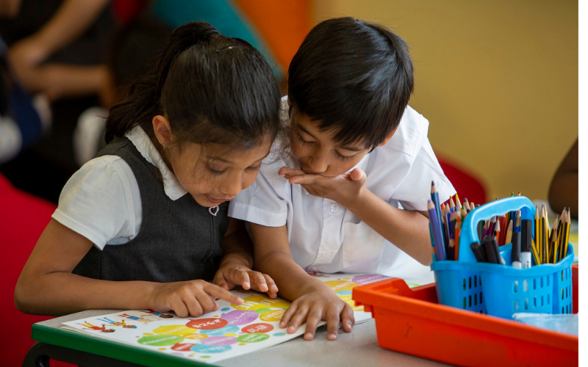

**Image:** <https://wels.open.ac.uk/news/new-course-support-children%E2%80%99s-reading-pleasure>

<https://www.indiatoday.in/magazine/cover-story/story/20230612-education-setting-a-new-course-2388463-2023-06-03>